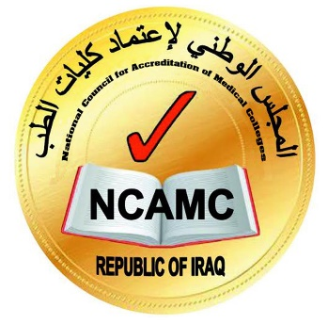

Guidelines on

Writing a Progress Report

Post Accreditation Period

By NCAMC

Feb 2024

Definition

A progress report is a document that an accredited (full or conditional) medical college should submit to the National Council for Accreditation of Medical Colleges within a defined time after the accreditation decision.

Timeline for submitting the Progress Report

Accreditation decision | 1st  year | First Follow-up  progress Report | 2nd  Year | 3rd  Year | 4th  Year | Second  Progress Report | 5th  year | 6th  year | Resubmit for Accreditation process

First Report (follow-up Progress Report)

Submitted at the end of the first year following the accreditation decision (full or conditional) and include.
- First Report Follow-up Template I (Standards Checklist form)

Second Progress Report

It should be submitted Before the end of 4th year for a fully accredited medical college from the first accreditation decision.
- Progress Report Template I (Standards Checklist form)
- Progress Report Template II (Program Major Changes)
The standards checklist includes all the standards, whether achieved or not achieved, in the accreditation decision report.

Progress Report Template I
Medical College Logo

1st/4th-year Progress Report
Post Accreditation Period

Checklist Form*

University Name
College Name
Report Date

Area
Standards
 | Evidence  "Describe in brief the type of Evidence you provide." | Annex No.
Present
Applied
Effective
*This checklist based on the report to the college by NCAMC at time of accreditation decision
This report was approved by the College Council of "College Name" and "University Name".

Medical College Stamp

Dean Name
Signature
Date

Progress Report Template II
Medical College Logo

4th-year Progress Report
Post Accreditation Period

Program Major Changes

University Name
College Name
Report Date

Section 1
Criteria | The medical college must state any change in the length or format of the program.
Guidance | The medical college must provide an old and updated version of the curriculum stating the program's format and length.

Answer

List of Evidence

Section 2
Criteria | The medical college must state any significant change in educational outcomes and mission.
Guidance | The medical college must provide an updated mission and outcome in addition to the old, stated mission and outcome at the time of decision.

Answer

List of Evidence

Section 3
Criteria | The medical college must state any change in student numbers relative to resources.
Guidance | the medical college must support old and new student intake strategies and how the resources will fit with new intake, if any.

Answer

List of Evidence

Section 4
Criteria | The medical college must state that any significant resource reduction leads to an inability to achieve the program's purpose and/or outcomes.
Guidance | The medical college must support evidence of maintenance and enrichment of its resources to support achieving its program (including Staff, infrastructure, laboratories, libraries, clinical teaching facilities and others)

Answer

List of Evidence

This report was approved by the College Council of "College Name" and "University Name".

Medical College Stamp

Dean Name
Signature
Date

